**CONNECTIVITY**

IDE-ATA

SCSI –uses HBA (host bus adapter)

(target and initiator) WWPN (worldwide port name)

SATA

SAS

FC (point to point-server and storage direct connection-not scalable; fabric connect-switches-scalable)

Uses HBA(host bus adapter)

FC over 10gbit ethernet

**SAS** drives are able to rotate so much **faster** (up to 15K RPM) than **SATA** drives (typically 7.2K RPM), seek times may be substantially **faster** by more than 2 times.



**ACCESSING STORAGE**

**BLOCK LEVEL (Fibre Channel,SCSI)**

Compute resource (App+ File System) access Storage

SAN, flexible,expensive

**FILE LEVEL (NAS access CIFS or NFS)**

Compute resource (App) access file system on storage

Os overhead on storage

Simpler

**OBJECT LEVEL**

Metadata is stored

**DIRECT ATTACHED STORAGE**

Internal disk drive, external attached storage array

Space limitations

**Performance criteria:**

**IOPS-IO operations per second:** measurement for the maximum number of reads and writes (transaction) to a storage device for a given unit of time (e.g. seconds)

**Latency (seconds)** is the total time for completing a requested operation and the requestor receiving a response

**IOPS vs Transfer rate calculations**

*MB/s* = *IOPS* * *B* ÷ *10*6

*IOPS* = *MB/s* * *10*6 ÷ *B*

*GB/day* = *MB/s* * *86.4*

*MB/s* = *GB/day* ÷ *86.4*

where ***B*** is block size in Bytes.

**RAID**

Hardware: more performance, host based (raid controller card), array based (host connects to array which includes raid controller and disks)

Software: os application overhead

**Techniques**

Spread data over disks

Strip size

Stripe size (depth) = disk number* strip size

Mirroring

Parity (holds missing data and rebuild upon failure)

Raid 0: full capacity, only for performance, no protection, striping

Raid 1: mirroring if disk fails, I/O redirect no recovery needed, 1 disk tolerant

Raid 10-nested raid: mirror (protection) and stripe (performance), min 4 disks (even number of disk needed)

Raid 3: 1 extra parity disk, data distributed over disks, if failure it is rebuilded

Raid 4: 1 extra parity disk, data no need to be distributed over disks

Raid 5: Parity is written across all disks, 1 disk tolerant

Raid 6: Parity is written across all disks two parity disk, 2 disk tolerant

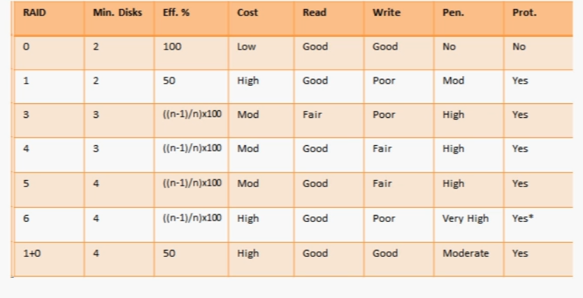

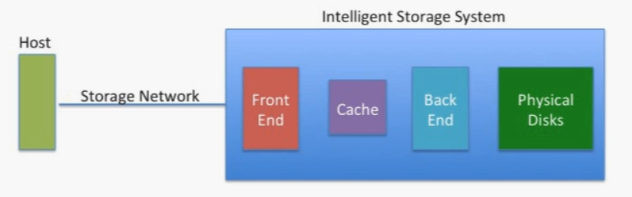

Backend: raid, error detection

Frontend: ports

Thick LUN: piece of raid set assigned to particular host

WWN-HBA storage adapters

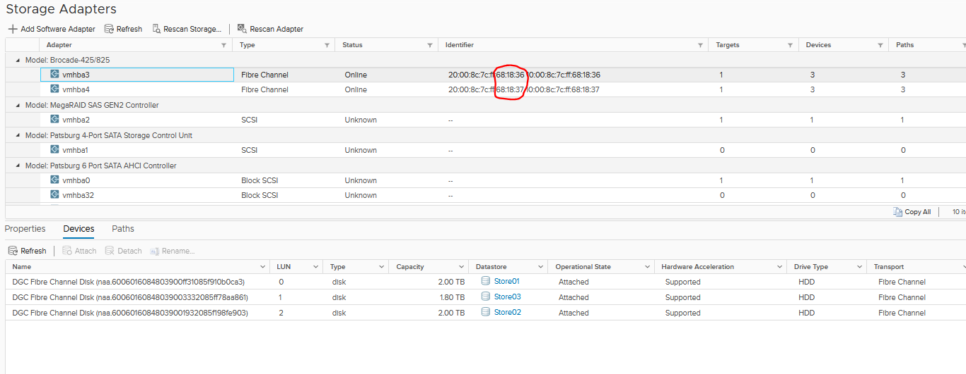

Finding hba wwn address

esxcli storage core adapter list | grep -i fc | awk ‘{print $4}’